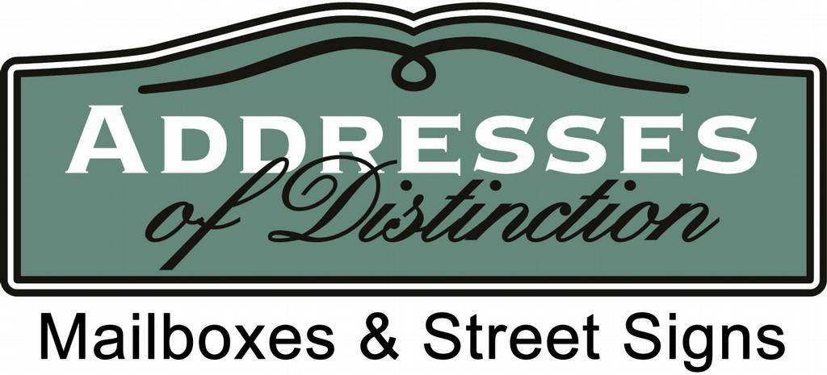

Refurbishment tips for Williamsburg Style Mailbox.

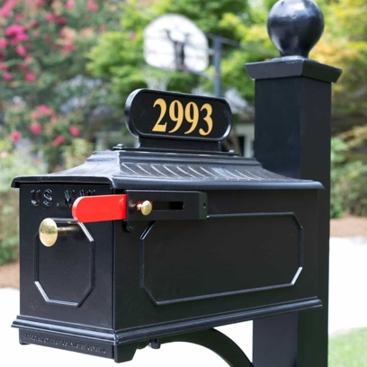

We suggest using a black oil-based brush on paint for bringing your mailbox up to code. Purchased from Sherwin-Williams.

If your mailbox has brass numbers, you can use any brass cleaner to clean them. If you prefer new numbers give us a call. We sell 2” brass and 3” brass numbers that are self-adhesive. We also can provide a new address plate that comes with numbers on both sides.

The knob or ring on the mailbox door can also be cleaned with brass cleaner. Give us a call if you would like to purchase a new knob, ring, or flag.

We currently do not offer individual refurbishments. If you have any questions we would be glad to answer them. We can be reached by phone at 770-436-6198, text 770-334-9302, or email supportdesk@aodmailboxes.com

