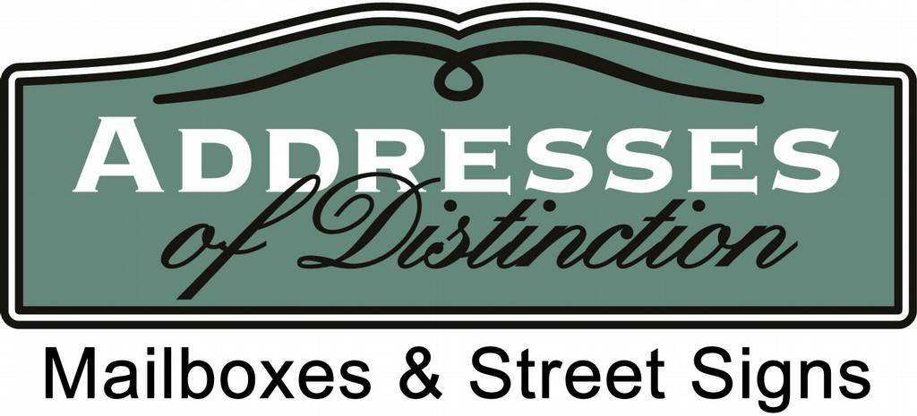

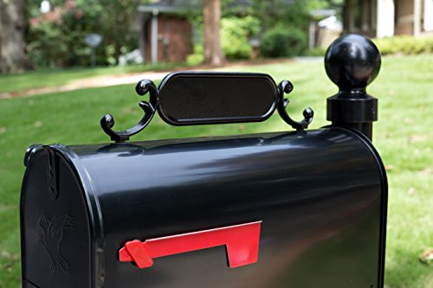

Mailbox refurbishments for standard mailboxes

We do not suggest painting the mailbox itself for this type. We do sell these in standard and large. We would just need the measurements of your mailbox to make sure we provide the correct one. Give us a call to purchase. We can replace flags if that is all you are needing for the box.

For the post and decorative bracket, we suggest using a black oil-based brush on paint for bringing your mailbox up to code. Purchased from Sherwin-Williams.

If your mailbox has brass numbers, you can use any brass cleaner to clean them. If you prefer new numbers give us a call. We sell 2” brass and 3” brass numbers that are self-adhesive. We also can provide a new address plate that comes with numbers on both sides.

We currently do not offer individual refurbishments. If you have any questions we would be glad to answer them. We can be reached by phone at 770-436-6198, text 770-334-9302, or email supportdesk@aodmailboxes.com

